Hi,all
Every developer in ERIS is headache of rebooting server when change java code ,and print a lot of useless debug log in most case just for there is no way to debug(add a breakpoint,watch...).
After some experiment,both of the problem can be solved now.
A.remote debug
With JPDA's help,We can debug application in weblogic with our favorite IDE(Eclipse,intellij idea,netbeans etc)
steps:
1.add following line to file setDomainEnv.cmd under weblogic %DOMAIN_HOME%\bin,this will cause weblogic use dt_socket mode for remote debug
set debugFlag=true
(See attached file: setDomainEnv.cmd)
2.config IDE ,take eclipse for example:
click run/debug configuration,add a new launch configuation for remote java application:
Connection type please select Standard(Socket Attach)
Host: weblogc's IP address(localhost if on same machine with debugger)
Port: 8453
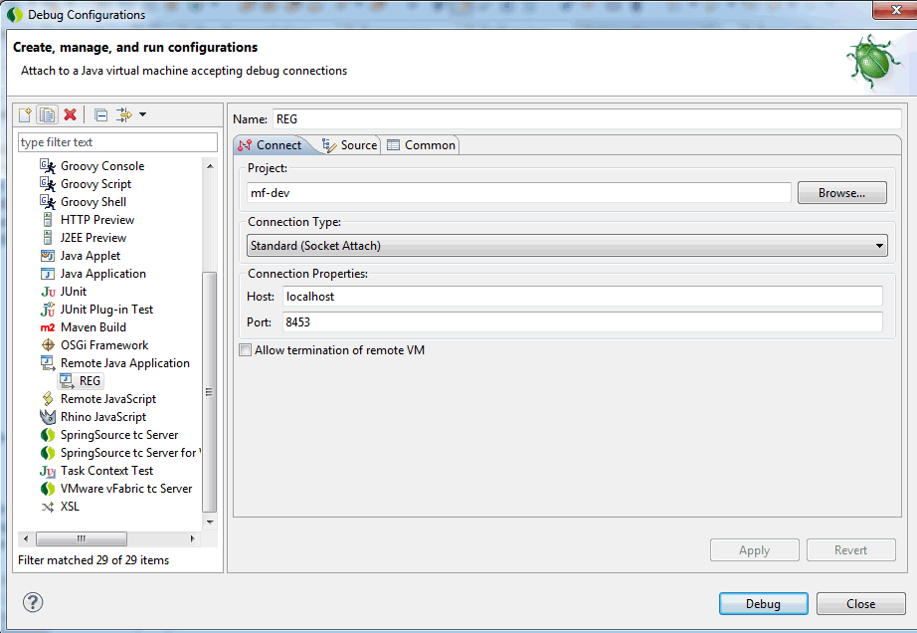
Then start the weblogic,whenever you want to debug ,you can use debug as...choose launch what you just configed ,then can attach the debugger to weblogic anytime.
B Hotswap code without rebooting:
This time,we can change our code in eclipse anythime without reboot server,and the result can immediately be shown.
Steps:
1.download the jrebel.jar(which I provide is a hacked verion,if want to buy a license,please go to jrebel site):
(See attached file: jrebel.jar)
2.Put it anywhere in weblogic server machine,then go to %DOMAIN_HOME%\bin and create the file startWeblogic-jrebel.cmd with the following contents:
@echo off
set JAVA_OPTIONS=-javaagent:"e:\jrebel.jar" %JAVA_OPTIONS%
call "%~dp0\startWebLogic.cmd" %*
please change the jrebel.jar's address as your own.
then from now on use this script to boot your weblogic.
3.add a rebel.xml to the root of your jar file,then your can propagate the changes from your eclipse workspace,the rebel.xml content should be like this:
<?xml version="1.0" encoding="UTF-8"?>
<application xmlns:xsi="http://www.w3.org/2001/XMLSchema-instance" xmlns="http://www.zeroturnaround.com" xsi:schemaLocation="http://www.zeroturnaround.com http://www.zeroturnaround.com/alderaan/rebel-2_0.xsd">
<classpath>
<dir name="E:/workspace/mf-dev/bin">
</dir>
</classpath>
</application>
Change the "E:/workspace/mf-dev/bin" to where you code's compile class location.
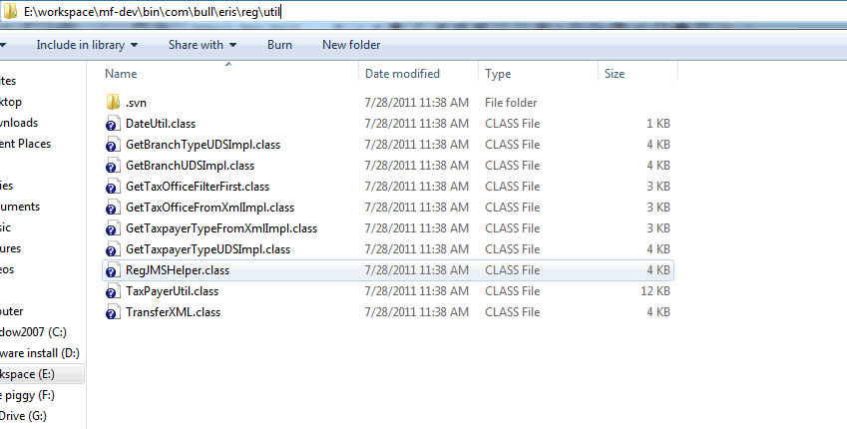
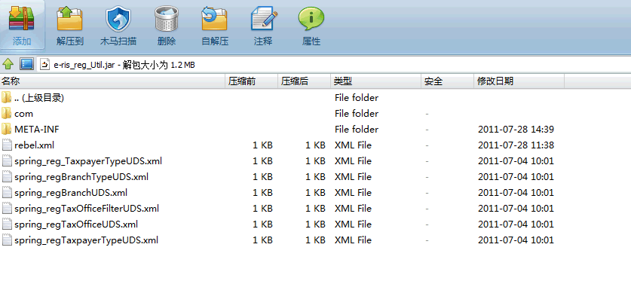
3.check eclipse project/build automatically choice on,then everytime your change your code in eclipse,the change can effect on server immediatelly.
ETA,DZIT cant aslo get benefit from it,just change the config accordingly.
Hope everyone can enjoy a more agile develop way

